Sec. 30-4.13. Building form standards.

This section contains the building form standards that determine the location, scale and massing of all buildings within the transects.

**Table V-2: Building Form Standards within Transects.**

|  |  |  |  |  |  |  |  |  |  |  |  |  |  |
| --- | --- | --- | --- | --- | --- | --- | --- | --- | --- | --- | --- | --- | --- |
| **TRANSECT** | **U1** | **U2** | | **U3** | **U4** | **U5** | **U6** | **U7** | **U8** | **U9** | | **DT** | |
| **A. BLOCK STANDARDS** | | | | | | | | | | | | | |
| Block perimeter (max. feet) | 2,600' | | | | | | | | | 2,000' | | 1,600' | |
| **B. LOT CONFIGURATION** | | | | | | | | | | | | | |
| Lot width (min. feet) | 34' | 18' | | | | | | | | 18' | | 18' | |
| **C. DEVELOPMENT INTENSITY** | | | | | | | | | | | | | |
| Nonresidential building coverage (max) | 60% | 80% | | | | | | | | 90% | | 100% | |
| Residential density by right (max. units per acre) (density bonuses above max. may be available2 ) | 25 | 35 | | 50 | 90 | 120 | 140 | 170 | 190 | 250 | | 425 | |
| **D. BUILDING FRONTAGE** | | | | | | | | | | | | | |
| Primary frontage (min) | 50% | 60% | | | | | | | | 70% | | 80% | |
| Secondary frontage (min) | 30% | 40% | | | | | | | | 50% | | 60% | |
| **E. BUILDING PLACEMENT** | | | | | | | | | | | | | |
| min-max. from curb |  |  | | | | | | | |  | |  | |
| min. landscape/min. sidewalk/min. building frontage |  | | | | | | | |  | |  |
| Storefront Street | 20'-25'  5'/10'/5' | 20'-25'  5'/10'/5' | | | | | | | | 20'-25'  5'/10'/5' | | 20'-25'  4'/10'/5' | |
| Principal Street | 17'-37'  6'/6'/5' | 17'-27'  6'/6'/5' | | | | | | | | 17'-27'  6'/6'/5' | | 17'-27'  6'/6'/5' | |
| Thoroughfare Street | 19'-100'  6'/6'/5' | 19'-100'  8'/6'/5' | | | | | | | | 19'-100'  8'/6'/5' | | 19'-100'  8'/6'/5' | |
| Local Street | 15'-35'  5'/5'/5' | 15'-20'  5'/5'/5' | | | | | | | | 16'-21'  5'/6'/5' | | 15'-20'  4'/6'/5' | |
| **F. BUILDING SETBACKS** | | | | | | | | | | | | | |
| Side interior setback (min) | 5' | 5' | | 5' | 5' | 5' | 5' | 5' | 0' | 0' | | 0' | |
| Rear setback (min) | 15' | 3' (alley) 10' (no alley) | | | | | | | | 3' (alley) 5' (no alley) | | 3' (alley) 0' (no alley) | |

**LEGEND:**

1 = See section 30-4.8 for development compatibility standards.

2 = See development bonus system in section 30-4.9 and affordable housing provision in section 30-4.31.

|  |  |  |  |  |  |  |  |  |  |  |
| --- | --- | --- | --- | --- | --- | --- | --- | --- | --- | --- |
| **TRANSECT** | **U1** | **U2** | **U3** | **U4** | **U5** | **U6** | **U7** | **U8** | **U9** | **DT** |
|  | TableV-2.png | | | | | | | | | |
| **G. BUILDING HEIGHT** | | | | | | | | | | |
| Min. feet | NA | NA | NA | NA | NA | NA | 18 | 18 | 18 | 18 |
| Max. stories (by right1 /with bonus2 ) | 3 | 3 | 3 | 3 | 4 | 4/5 | 4/6 | 5/6 | 6/8 | 12/14 |
| Max. feet (by right/with bonus2 ) | 36 | 36 | 36 | 42 | 60 | 60/74 | 60/88 | 74/88 | 88/116 | 172/200 |
| **H. FLOOR HEIGHT** | | | | | | | | | | |
| Min. first floor height (residential/nonresidential) | NA/10' | NA/12' | NA/12' | NA/12' | NA/12' | NA/12' | 12'/12' | 12'/15' | 12'/15' | 12'/15' |
| **I. GLAZING** | | | | | | | | | | |
| Min. first floor - nonresidential | - | 30% | | | 50% | | | | 65% | |
| Min. first floor - multi-family | - | 30% | | | | | | | | |
| Min. upper floors - nonresidential and multi-family | - | 15% | | | | | | | | |

**LEGEND:**

1 = See development compatibility standards in section 30-4.8.

2 = See development bonus system in section 30-4.9 and affordable housing provision in section 30-4.31.

A. *Block standards.*

1. *Maximum block perimeter.* Maximum block perimeters are defined Table V-2 for each transect. When development cumulatively includes 50% or more of the total project area, it shall be required to include new local streets or urban walkways and the resulting block(s) shall not exceed the prescribed maximum block perimeter. Figure V-1 below depicts a recommended approach to breaking down large blocks to provide a new street grid on a large site.

Figure V-1: Creating Blocks

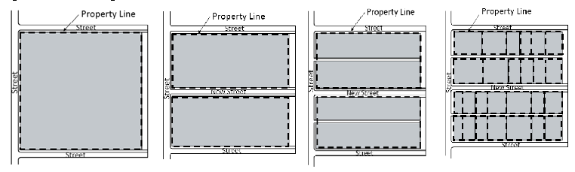

Step 1-original site; Step 2-introduce streets; Step 3-introduce alleys; Step 4-introduce lots.

2. *Construction of new streets.*

a. The required local streets or urban walkways shall be constructed at the expense of the owner/developer as part of the development review process and shall be constructed according to the appropriate city standards, but may be sited and configured in a manner so that they provide the most appropriate access to the development. Where a street is planned to continue beyond the extent of a development, the development shall provide for the continuation of the street by stubbing out the improvements as close as is practicable to edge of the property boundary.

b. The required local streets, multi-use paths or urban walkways shall provide for public access and may be dedicated for public right-of-way after construction, if the city desires to accept same for maintenance.

c. Notwithstanding any other provision in this chapter, a development may receive final approval prior to construction of the required local streets or urban walkways if the city, upon approval of the city commission, has executed a binding agreement with the owner/developer that:

i. Requires the city and/or the community redevelopment agency to construct the required local streets as public streets within two years of final approval; and

ii. Provides for the conveyance or dedication of the associated right-of-way from the property owner to the city, at no cost to the city.

The city may enter into such an agreement only when the city determines that doing so would be in the public interest and when the city and/or the community redevelopment agency has budgeted legally available funds for the construction of the required local streets. The form and content of the agreement shall be provided by and acceptable to the city in its sole discretion.

d. Board modifications from the requirement to construct new streets may be granted in accordance with the procedures and criteria for a variance, with specific consideration given to situations where the construction of a street is limited by: access management standards, regulated environmental features, regulated natural or archeological resources, public stormwater facilities, existing utility facilities, contamination sites, inconsistencies with plans for a future city street network, parks, or schools. Where a variance from these requirements is approved, the block perimeter shall be completed with the provision of sidewalk and bicycle connections, and multi-use paths or urban walkways, subject to approval by the city.

3. *Urban walkways.* When required new streets or urban walkways are constructed as part of a subdivision or development, their design and construction shall conform to the following standards and applicable design manual standards:

a. New streets or urban walkways shall connect to existing streets on abutting properties, or be constructed in alignment with planned public streets on abutting properties.

b. Where a portion of a new street or urban walkway is newly constructed, it shall be designed to be extended to abutting property. Stub-outs shall extend to the property line.

c. Urban walkways shall be a minimum of 26 feet wide and may be designed with a single or divided paved pathway. The pathway(s) shall be at least ten feet wide in total width and shall provide for both bicycles and pedestrians. An urban walkway shall be landscaped with shade trees on minimum 50-foot centers on both sides of the paved path. Unpaved areas may also contain stormwater facilities. Urban walkways may contain benches, fountains, outdoor cafes or other outdoor uses as long as a minimum sidewalk width as specified above is maintained.

B. *Building frontage.* Building frontage requirements are intended to help frame the public realm by creating continuous building presence along streets.

1. The building frontage standards are a proportion of the building length relative to the width of the development site measured at the site frontage line, (see Figure V-3). Building frontage standards do not apply to new single-family dwelling construction.

**Figure V-3: Building Frontage**

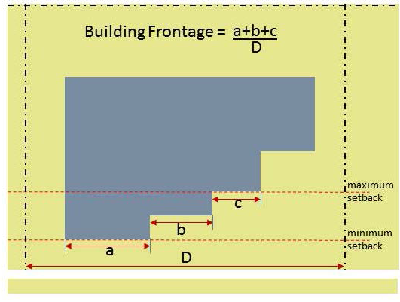

2. *Frontage hierarchy.*

a. Where a development has frontage along multiple street types that do not include a thoroughfare, the urban street (storefront or principal, in that order of hierarchy) shall be considered the primary street for the front face of the building.

b. Where a development has frontage on a thoroughfare and any other street type, the thoroughfare shall be considered the primary street.

c. Where a development has frontage on two streets of equal type, then the city manager or designee shall make a determination as to which street frontage shall be considered primary.

**Figure V-4: Example of Gateway**

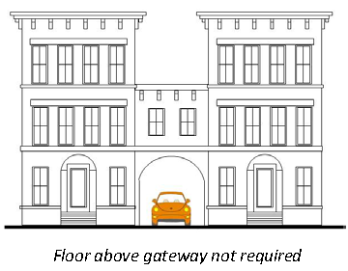

3. Outdoor seating areas, when located within the min/max street setback, may be counted towards meeting (up to 30%) the required building frontage requirements. Outdoor seating must be located behind a 3-4-foot screening wall that is integral and aligned with the front building facade. The wall must be architecturally consistent with the materials of the adjoining facade.

4. The appropriate reviewing board may consider alternative proposals for meeting building frontage requirements, including public art installations, innovative and unique landscape/hardscape improvements, or similar methods, which enhance the public realm and create a consistent urban form along the street.

5. A preserved high quality heritage tree canopy within the street setback range may count towards meeting the building frontage requirement.

6. The ground floor along the street frontages must contain active uses oriented to the street. Active uses may include, but are not limited to, display or floor areas for retail uses; waiting and seating areas for restaurants; atriums, lobbies, amenity areas, or dining areas for hotels or multi-family residential buildings; or ground floor offices. Active uses must be concentrated along storefront and principal designated streets. In the event that all of the abutting roadways are local streets, active ground floor uses must be concentrated along the most primary local street as determined by existing or anticipated pedestrian traffic.

7. In order to make ground floor commercial spaces viable and ready for operation, the owner/developer shall complete, prior to the issuance of any Certificate of Occupancy for the associated building or development, the installation of all mechanical, electrical plumbing, and fire protection infrastructure necessary for general tenant operability. The owner/developer shall also provide exhaust ventilation and grease interceptors during construction of the initial building shell. Grease interceptor size will be determined by GRU during the grease trap/interceptor permitting process and must provide adequate capacity to serve all prospective ground floor tenant spaces.

C. *Building placement and setbacks.* The placement of a building on a site is critical to creating a vital and coherent public realm. The building placement and setback standards shall shape the public realm and strengthen the physical and functional character of the area. Figure V-5 depicts the types of setbacks.

**Figure V-5: Building Setbacks**

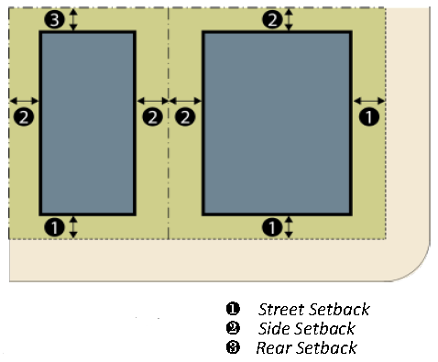

1. Building placement requirements shall be measured from the back of curb instead of the front property line, with the following exceptions:

a. In the absence of curbs, shall be measured from the edge of pavement.

b. Where the required building placement falls within a public right-of-way, it shall be shifted to the property line instead.

2. Building placement requirements shall be comprised of a landscape zone, a public sidewalk zone and a building frontage zone. Figure V-6 depicts the required configuration of these zones in relation to the street curb and building. The required minimum widths for the landscape and sidewalks zones are listed within Table V-2. The building frontage zone shall be a minimum of five feet in all locations. Section 30-4.13 D. contains additional standards for the design of the building frontage zone.

**Figure V-6: Public Realm Zones**

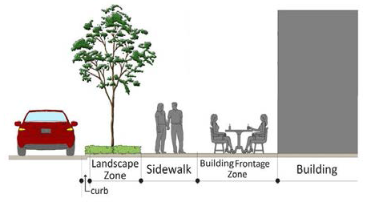

3. Side and rear setbacks are minimums and shall be measured from shared property lines.

4. The following shall not be located within the public sidewalk zone; utility poles including electrical transmission and distribution poles; light poles; mechanical equipment as defined in section 30-6.10; signs included in section 30-9.2A; and street furniture including benches, trash receptacles, and bicycle racks.

5. Where multiple buildings are proposed within a development, the placement of buildings at the rear of a site is allowed as long as one or more buildings are placed along the front of the site meeting the building placement and setback and building frontage requirements of this division. Figure V-7 depicts the required configuration of multiple buildings on a site, such as within a shopping center. Streets or access drives shall be incorporated into the site to break it down into smaller lots/blocks (platting will not be required). The primary access drive shall be centered on the anchor building and shall be lined with buildings, which shall meet the required frontage standards along the street and access drive.

Figure V-7: Multiple Buildings on a Site

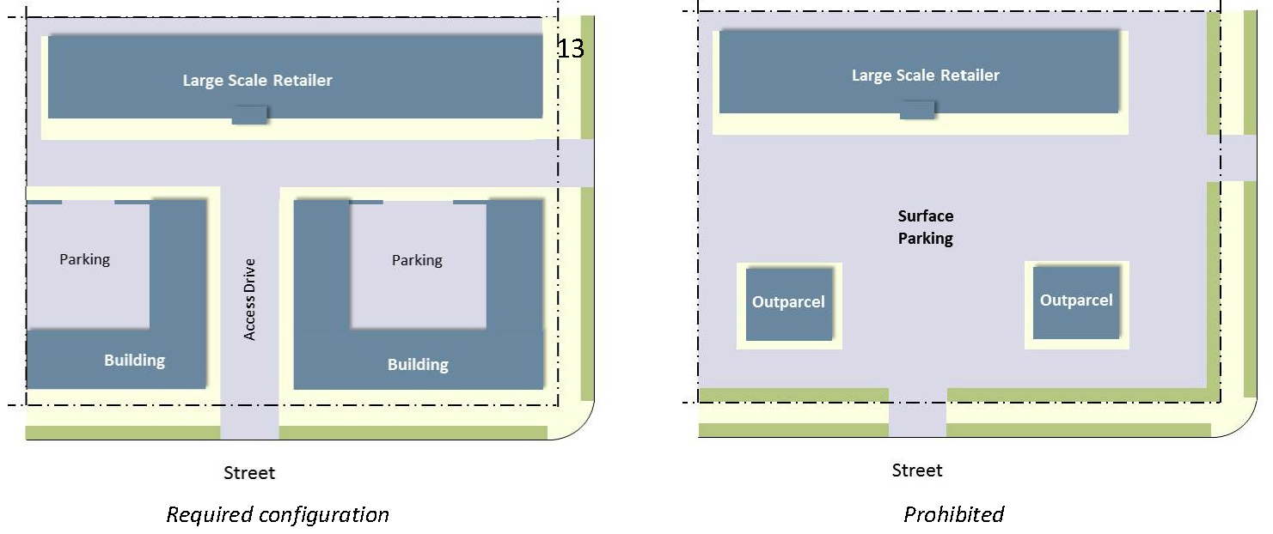

D. *Building frontage zone requirements.* All development shall provide a minimum five-foot wide building frontage zone behind the public sidewalk, and buildings shall have at least one type of building frontage incorporated into its design. Table V-3 contains the dimensional requirements for the various types of building frontages allowed. The intent of the building frontage zone is to provide a transition between the public street/sidewalk and the building. The type of activity conducted in the private frontage zone depends on the nature of the proposed use (Figure V-8). For a commercial building, the intent of the private frontage zone is to attract customers into the business. For a residential site, the intent of the private frontage zone is to provide for a private outdoor space and establish a separation from the public sidewalk for the ground floor rooms.

Figure V-8: Examples of Building Frontage Zone Activity

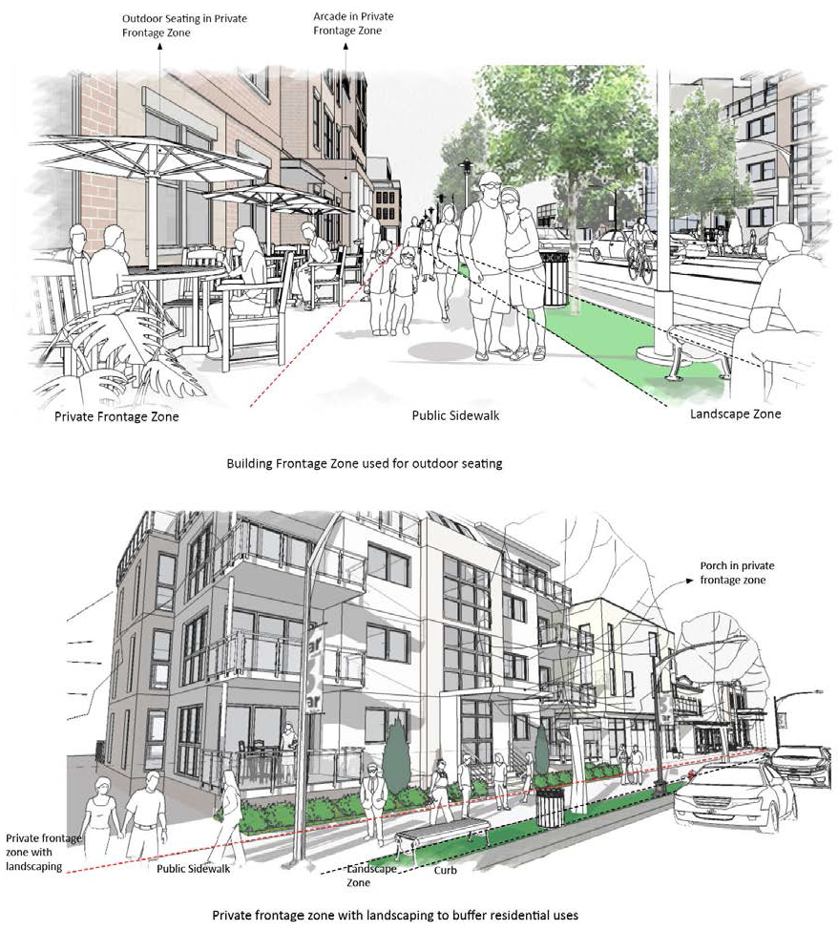

**Table V-3: Building Frontage Dimensional Standards**

|  |  |  |
| --- | --- | --- |
| **Storefront** | **Gallery** | **Arcade** |
| TableV-3storefront.png | TableV-3Gallery.png | TableV-3Arcade.png |
| 1. Width: 25% of façade width min. | 1. Width: 75% of façade width min. | 1. Width: 75% of façade width min. |
| 2. Depth: 5' min. | 2. Depth: 8' min. | 2. Depth: 8' min. |
| 3. Clear Height: 8' min. |  |  |
| 3. Clear Height: 12' min. (1st floor) | 3. Clear Height: 12' min. (1st floor) |  |
| **Courtyard** | **Stoop** | **Porch** |
| TableV-3Courtyard.png | TableV-3Stoop.png | TableV-3Porch.png |
| 1. Width: 10' min. to 50% of façade width max. | 1. Width: 5' min. to 16' max. | 1. Width: 12' min. |
| 2. Depth: 10' min/20' max. | 2. Depth: 5' to 8' | 2. Depth: 8' min. |
| 3. Elevation: 18" max. above grade. | 3. Clear Height: 8' | 3. Clear Height: 8' min. |
|  | 4. Elevation: 21" min. above grade. | 4. Elevation: 21" min. above grade. |

**Note:** See Article II for definitions of frontages.

1. *Building frontage standards, general.*

a. In addition to the encroachments shown in Table V-3, cantilevered balconies, bay windows and roof overhangs are allowed to encroach into the building frontage zone.

b. Street furniture such as benches, trash receptacles, or bicycle racks may be installed within the building frontage zone; however, permanent fencing is prohibited.

2. *Standards for storefronts, awnings and canopies.*

a. Storefront doors shall not be recessed more than five feet from the front façade. Recessed doors shall have angled walls leading to the door to promote the visibility of the entrance.

b. Awnings and canopies shall not cover building architectural elements including but not limited to cornices or ornamental features.

c. High gloss or plasticized fabrics and aluminum are not allowed for awnings.

d. Backlit awnings are not permitted.

e. Awning shall match the width of the window or door opening and shall enhance the architectural features of the building.

3. *Standards for galleries and arcades.*

a. Along urban Storefront streets, gallery/arcade openings shall align with storefront entrances.

b. Galleries may be one or two stories.

c. Arcades and galleries shall have consistent depth along a frontage.

4. *Standards for courtyards.*

a. Courtyards shall be paved and a minimum of 20 percent of the total courtyard area shall be enhanced with either above-ground or in-ground landscaping.

5. *Standards for stoops and porches.*

a. Stoops shall align directly with the building entry.

b. Porches may be one or two stories.

c. Porches may encroach into the building frontage zone.

E. *Building height.*

**Figure V-9: Building Height**

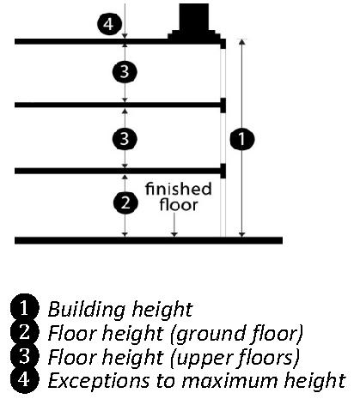

1. The heights of parking structures shall be limited in accordance with the maximum feet within each district, but shall not be limited to the maximum number of stories.

2. Mezzanines that meet the definition and requirements of the Florida Building Code shall not be counted as an additional story.

3. The building height limitations contained in Table V-2 do not apply to spires, belfries, cupolas, antennas, water tanks, ventilators, chimneys or other appurtenances required to be placed on the roof and not intended for human occupancy. Other exceptions include:

a. Roof structures above eave line can vary in height up to a maximum of 15 feet above eave line.

b. Trellises may extend above the maximum height up to eight feet.

F. *Floor height.*

1. Floor height shall be measured as provided in the Florida Building Code.

2. Parking garages are exempt from the minimum floor height requirements.

(Ord. No. 170831, § 4, 4-5-18; Ord. No. 170971, § 2, 2-21-19; Ord. No. 170974, § 6, 2-21-19; Ord. No. 200730, § 2, 2-17-22; Ord. No. 211359, § 7, 10-17-22; Ord. No. 2023-169, § 7, 6-1-23; Ord. No. 2022-679, § 4, 9-19-24; Ord. No. 2024-263, § 5, 10-3-24)